7 December 2012

[www.signafrica.co.za](http://www.signafrica.co.za) Keys Communications unlocks alternative media R20 000

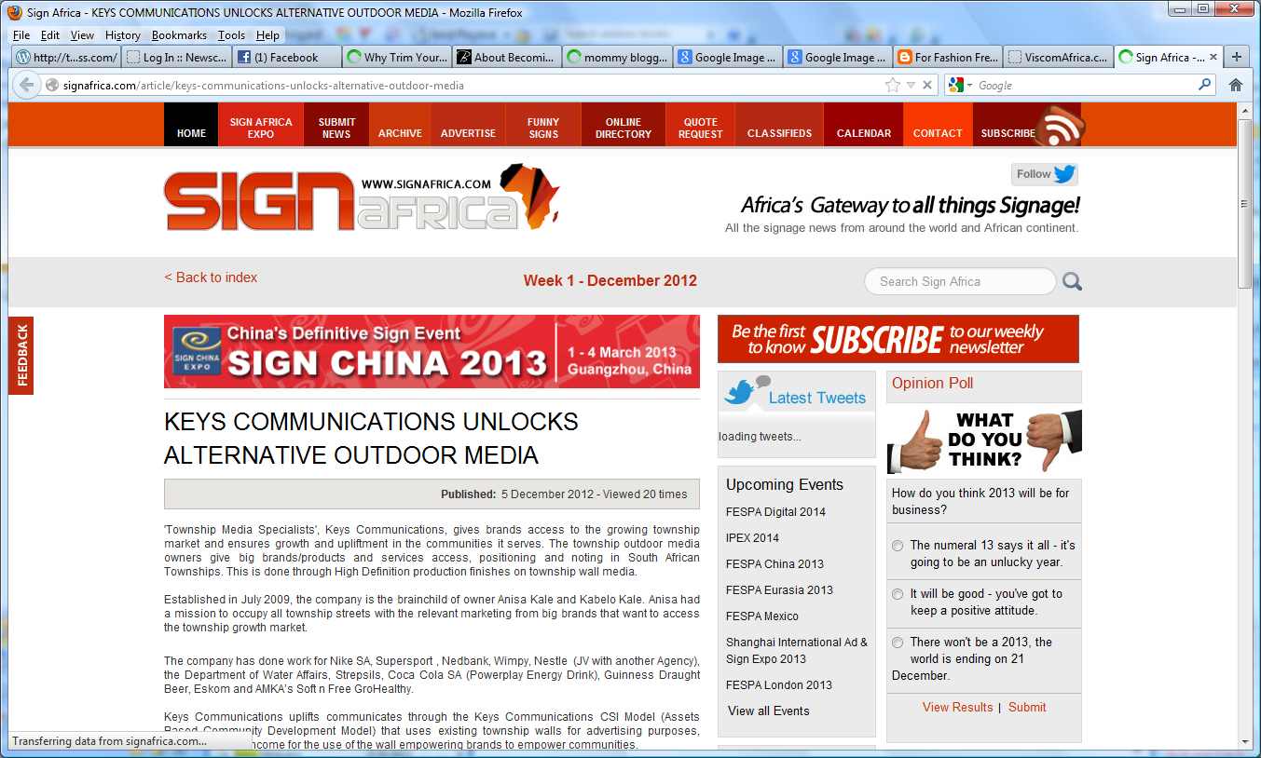

http://signafrica.com/article/keys-communications-unlocks-alternative-outdoor-media